Azure Virtual Desktop Setup 11/11/2025

We’re using the following link in this tutorial:

https://www.youtube.com/watch?v=Y5AB7AShdi0

To set up an Azure Virtual Desktop Hosting pool we need to complete the following tasks:

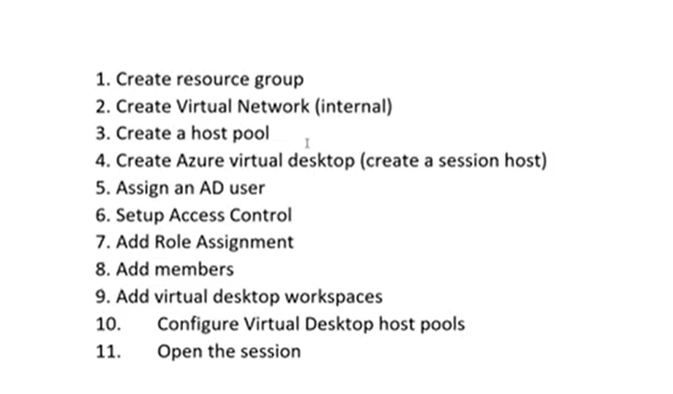

The first task (to create a resource group) is intended to group all of the objects which you need (for your service) into a container/bucket of resources which can then be referenced across your azure tenancy/subscription:

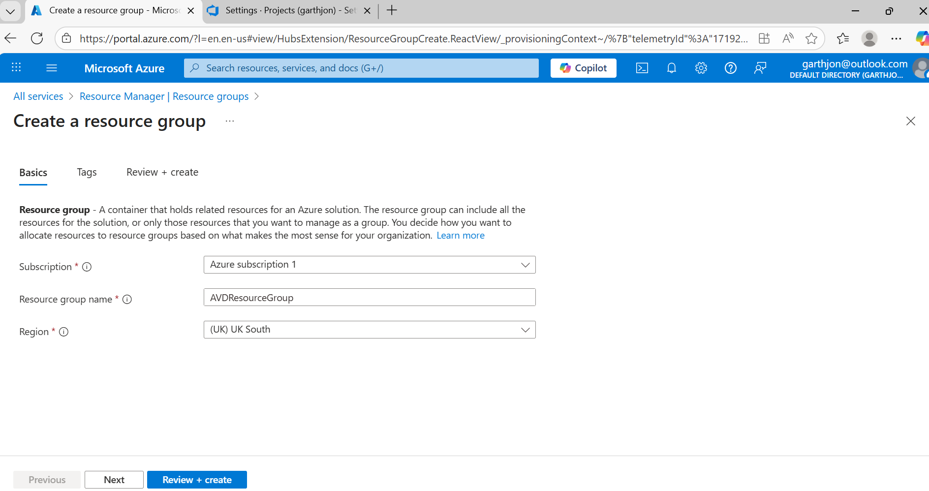
Note that I have given the resource group name a meaningful name i.e. AVDResourceGroup because I am creating an Azure Virtual Desktop Service (a test hosting service to provide researcher virtual machines/desktops and virtual workspaces within those virtual machines/desktops).
Note also that it is important that all objects/resources are set up within the same region, so I’m choosing: ‘UK South’.

Next we create a Virtual Network, and a subnetwork within this Virtual Network and this is essentially a range of IP addresses that we can use for the objects which we are going to create within the Resource Group [and therefore our AVDDesktop service] and those objects will mainly be virtual machines/virtual desktops within a [virtual machine] hosting pool [which will also exist within the resource group which we have created].
So make use that your virtual network is meaningfully names in relation in relation to the service which you are building [I called mine AVDVirtualNetwork], also ensure that it is in the same region as your resource group;

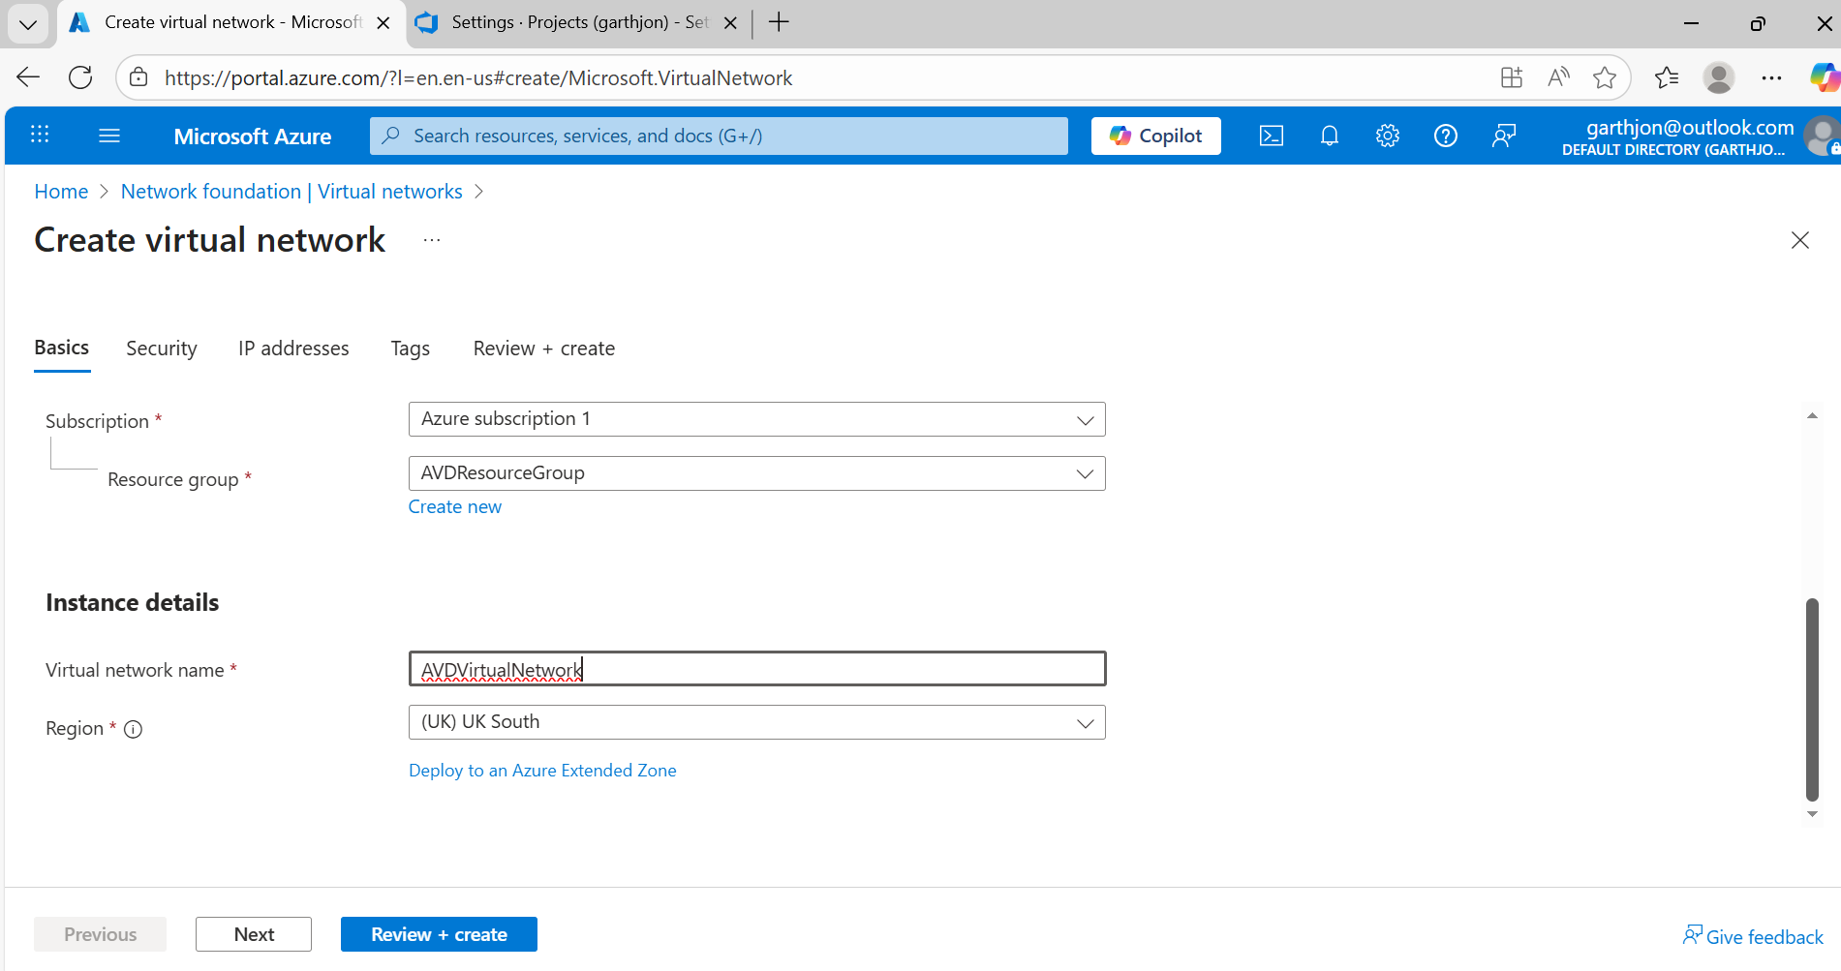

so we need to provision a network which has at least 256 ip addresses, in order that it can accommodate at least one subnet with 256 addresses;

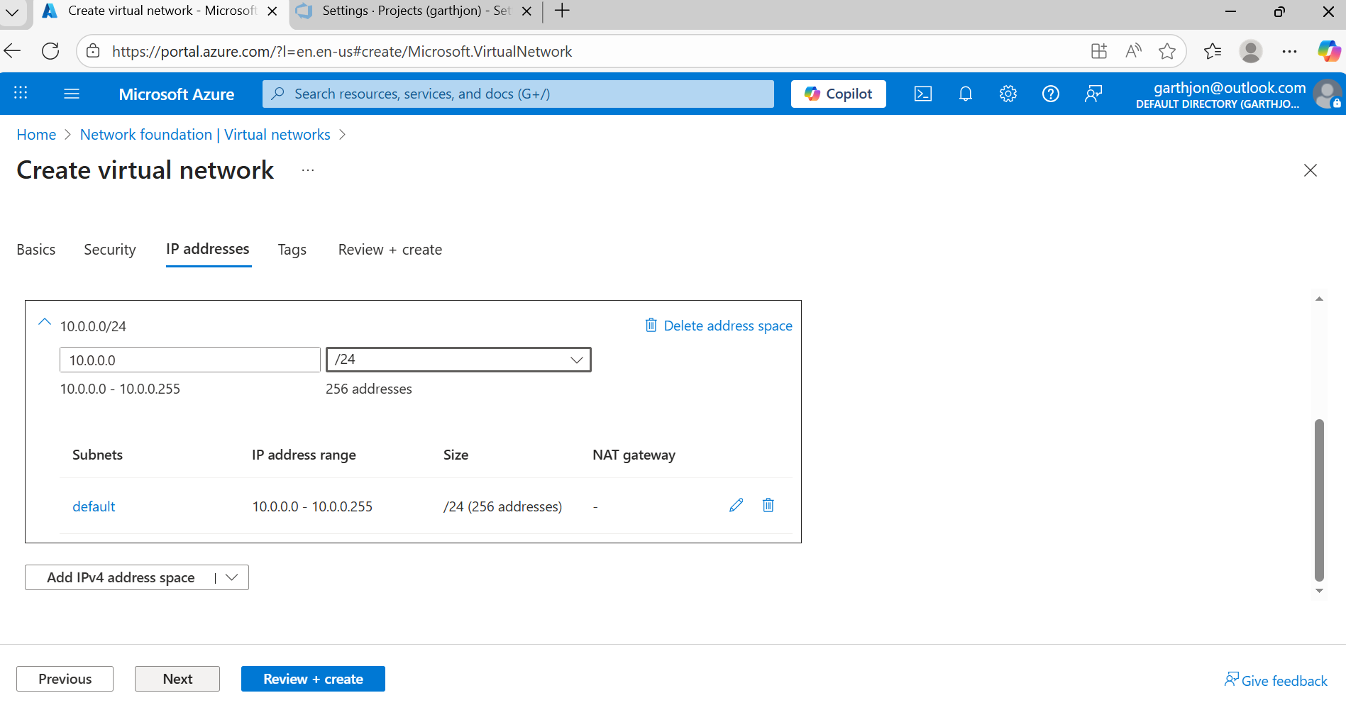

and the virtual network and the subnet are validated and created –

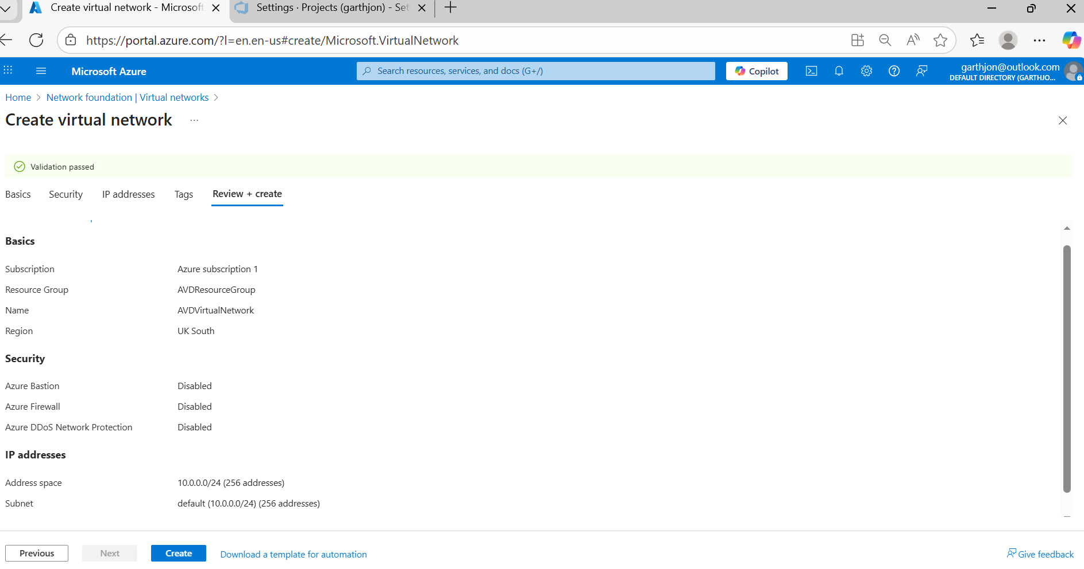

before creating virtual desktops we have to create a host pool within which to host the virtual desktops, so head over to ‘azure virtual desktop’, we call the hostpool a meaningful name and set host pool type to be ‘pooled’ rather than personal so that multiple users can use the virtual desktop simultaneously;

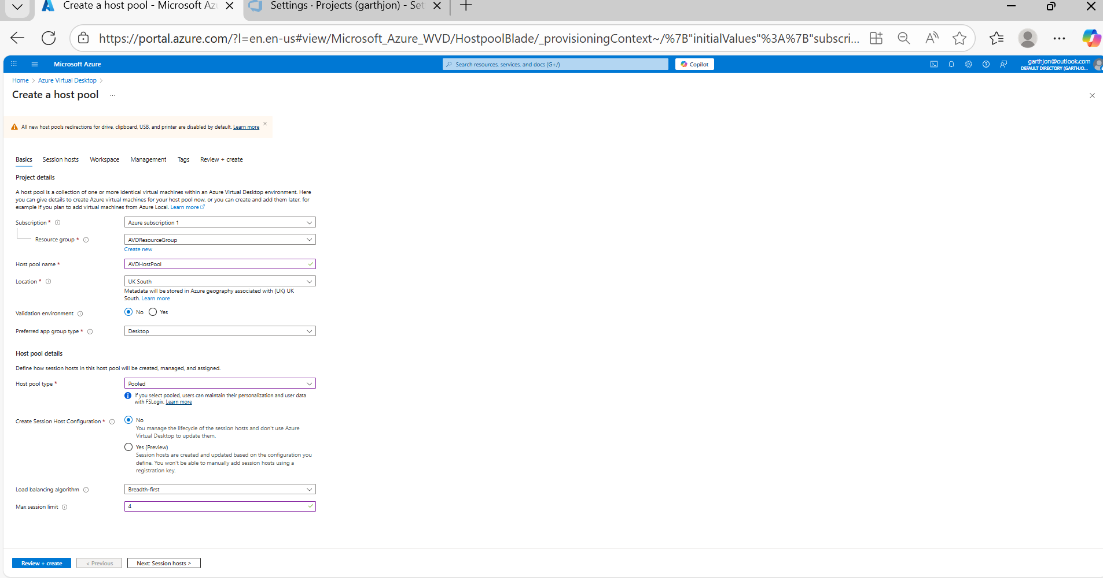

we elect to create a ‘pool’ of virtual machines at this stage and we name that vm pool AVDHostPool

